5.104: Recognizing the geometry of a 3-4-5 right triangle simplifies the calculation. For instance, the radius of the circle of the mass’ motion is 0.75 m.
a) Balancing the vertical force, 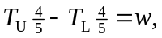 so
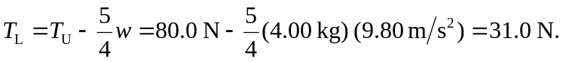
b) The net inward force is 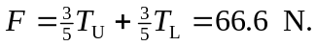 Solving 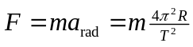 for the period T,
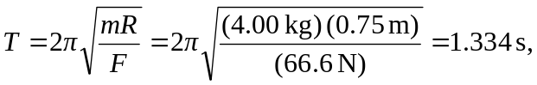
or 0.02223 min, so the system makes 45.0 rev/min. c) When the lower string becomes slack, the system is the same as the conical pendulum considered in Example 5.22. With 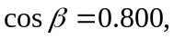 the period is which is the same as 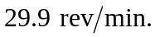 d) The system will still be the same as a conical pendulum, but the block will drop to a smaller angle.

